**How to generate a shadowpix using the local method**

Run the shadowpix_local.py script in order to generate a shadowpix. You can set the following parameters (inside the script):

1. theta_deg – the angle of the directional light source with the z-axis (as in paper)
2. image1_path – a path to the first image
3. image2_path – a path to the second image
4. image3_path – a path to the third image
5. output_dir – the output directory path

After running the script, the output folder will contain the following results:

1. receivers.txt – heights for the shadowpix receivers
2. x_casters.txt - heights for the shadowpix X casters (‘u’ in the paper)
3. y_casters.txt - heights for the shadowpix Y casters (‘v’ in the paper)
4. recon_image1.png – image1 reconstructed from the shadowpix
5. recon_image2.png – image2 reconstructed from the shadowpix
6. recon_image3.png – image3 reconstructed from the shadowpix

**Unity simulator**

The ‘sim_exe’ folder contains an example for a deployed unity simulator.

The outputs of the above script should be stored in ‘sim_exe/Assets/’.

When running ‘ShadowPixSimulator.exe’, on the configuration window select ‘Ultra’ quality, as shown below:

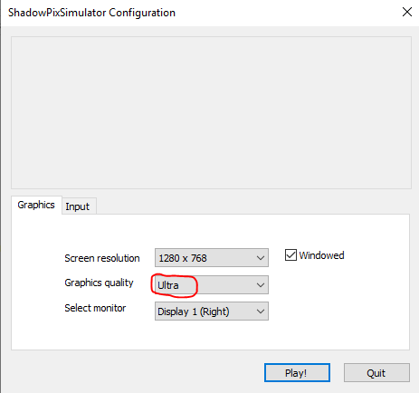

While the simulator is running, enable only one of the light sources at a time, using the light toggles (‘Light A’, ‘Light B’ and ‘Light C’).

The ‘Enable Camera Rotation’ toggle enables rotating the camera using the mouse.

The source code for the simulator is located at ‘ShadowPixSimulator’.